**CONTENTS**

1.INTRODUCTION

1.1 INTRODUCTION TO PROJECT

1.2 ORGANIZATION PROFILE

1.3 PURPOSE OF THE PROJECT

1.4 PROBLEM IN EXISTING SYSTEM

1.5 SOLUTION OF THESE PROBLEMS

1. SYSTEM ANALYSIS
   1. INTRODUCTION
   2. SYSTEM WORKFLOW
   3. STUDY OF THE SYSTEM
   4. HARDWARE & SOFTWARE REQUIRMENT
   5. PROPOSED SYSTEM
   6. INPUT & OUTPUT
   7. PROCESS MODELS USED WITH JUSTIFICATION
2. FEASIBILITY REPORT
   1. TECHNICAL FEASIBILITY
   2. OPERATIONAL FEASIBILITY
   3. ECONOMIC FEASIBILITY
3. SOFTWARE REQUIREMENT SPECIFICATIONS
   1. FUNCIONAL REQUIREMENTS
   2. PERFORMANCE REQUIREMENTS
4. SELECTED SOFTWARE
   1. INTRODUCTION TO XAMPP v3.2.4
   2. PHP
   3. HTML/CSS
   4. SQL SERVER
5. SYSTEM DESIGN
   1. INTRODUCTION
   2. SYSTEM WORKFLOW
   3. NORMALIZATION
   4. E-R DIAGRAM
   5. DATA FLOW DIAGRAMS
   6. DATA DICTIONARY
6. OUTPUT SCREENS
7. SYSTEM TESTING AND IMPLEMENTATION
   1. INTRODUCTION
   2. STRATEGIC APPROACH OF SOFTWARE TESTING
   3. UNIT TESTING
   4. TEST
8. SYSTEM SECURITY
   1. INTRODUCTION
   2. SECURITY IN SOFTWARE

10 CONCLUSION

# CHAPTER 1 INTRODUCTION

## 1.1. INTRODUCTION TO PROJECT – LIBRARY MANAGEMENT SYSTEM PROJECT

The Easy Leave is an Intranet based application that can be accessed throughout the organization or a specified group/Dept. This system can be used to automate the workflow of leave applications and their approvals. The periodic crediting of leave is also automated. There are features like email notifications, cancellation of leave, automatic approval of leave, report generators etc in this Tool.

The project has been planned to be having the view of distributed architecture, with centralized storage of the database. The application for the storage of the data has been planned. Using the constructs of MS-SQL Server and all the user interfaces have been designed using the ASP.Net technologies. The database connectivity is planned using the “SQL Connection” methodology. The standards of security and data protective mechanism have been given a big choice for proper usage. The application takes care of different modules and their associated reports, which are produced as per the applicable strategies and standards that are put forwarded by the administrative staff.

## 1.2. PURPOSE OF THE PROJECT – LIBRARY MANAGEMENT SYSTEM PROJECT

This project is aimed at developing a web based Leave Management Tool, which is of importance to either an organization or a college. This is an Intranet based application that can be accessed throughout the organization or a specified group/Dept. This system can be used to automate the workflow of leave applications and their approvals. The periodic crediting of leave is also automated. There are features like email notifications, cancellation of leave, automatic approval of leave, report generators etc in this Tool

## 1.3. PROBLEM IN EXISTING SYSTEM

* Cannot Upload and Download the latest updates.
* No use of Web Services and Remoting.
* Risk of mismanagement and of data when the project is under development.
* Less Security.
* Fewer Users - Friendly.

## 1.4. SOLUTION OF THESE PROBLEMS

The development of the new system contains the following activities, which try to automate the entire process keeping in view of the database integration approach.

1. User friendliness is provided in the application with various controls.
2. The system makes the overall project management much easier and flexible.
3. Readily upload the latest updates, allows user to download the alerts by clicking the URL.
4. There is no risk of data mismanagement at any level while the project development is under process.
5. It provides high level of security with different level of authentication.

**CHAPTER 2**

# SYSTEM ANALYSIS

## 2.1. INTRODUCTION

After analyzing the requirements of the task to be performed, the next step is to analyze the problem and understand its context. The first activity in the phase is studying the existing system and other is to understand the requirements and domain of the new system. Both the activities are equally important, but the first activity serves as a basis of giving the functional specifications and then successful design of the proposed system. Understanding the properties and requirements of a new system is more difficult and requires creative thinking and understanding of existing running system is also difficult, improper understanding of present system can lead diversion from solution.

## 2.2. ANALYSIS MODEL - EMPLOYEE LEAVE MANAGEMENT SYSTEM PROJECT

The model that is basically being followed is the WATER FALL MODEL, which states that the phases are organized in a linear order. First of all the feasibility study is done. Once that part is over the requirement analysis and project planning begins. If system exists one and modification and addition of new module is needed, analysis of present system can be used as basic model.

The design starts after the requirement analysis is complete and the coding begins after the design is complete. Once the programming is completed, the testing is done. In this model the sequence of activities performed in a software development project are: -

* Requirement Analysis
* Project Planning
* System Design
* Detail Design
* Coding
* Unit Testing
* System Integration & Testing

Here the linear ordering of these activities is critical. End of the phase and the output of one phase is the input of other phase. The output of each phase is to be consistent with the overall requirement of the system. Some of the qualities of spiral model are also incorporated like after the people concerned with the project review completion of each of the phase the work done.

WATER FALL MODEL was being chosen because all requirements were known beforehand and the objective of our software development is the computerization/automation of an already existing manual working system.

**2.3. STUDY OF THE SYSTEM - EMPLOYEE LEAVE**

# MANAGEMENT SYSTEM PROJECT

## GUI’S

In the flexibility of the uses the interface has been developed a graphics concept in mind, associated through a browses interface. The GUI‟S at the top level have been categorized as

1.Administrative user interface

2.The operational or generic user interface

The administrative user interface concentrates on the consistent information that is practically, part of the organizational activities and which needs proper authentication for the data collection. The interfaces help the administrations with all the transactional states like Data insertion, Data deletion and Date updation along with the extensive data search capabilities.

The operational or generic user interface helps the users upon the system in transactions through the existing data and required services. The operational user interface also helps the ordinary users in managing their own information helps the ordinary users in managing their own information in a customized manner as per the assisted flexibilities.

## NUMBER OF MODULES

The system after careful analysis has been identified to be presented with the following modules:

The modules involved are:

* Admin
* Principal
* HOD
* Faculty

ADMIN

In this Module. The admin can view the feedback from all the employee about the software.

PRINCIPAL

In this Module. The principal can add department as well as leave type and principal can as manage the hod‟s and leaves that can be applied by hod . the principal can also give a feedback about product that can be view by admin.when the principal appoved or rejected the leave it can also send mail to hod as notification .

HOD

In this Module. The hod can add faculty to that appropriate department and hod can manage faculty. When the leave is applied by faculty it will come to that appropriate hod module . and hod can appoved or rejected the leave it can also send mail to faculty as notification .

FACULTY

In this Module. The faculty can view a profile and he/she can apply a leave .

**2.4. HARDWARE SPECIFICATIONS - EMPLOYEE LEAVE**

# MANAGEMENT SYSTEM PROJECT

**HARDWARE REQUIREMENTS:**

* PIV 2.8 GHz Processor and Above
* RAM 512MB and Above
* HDD 20 GB Hard Disk Space and Above

**SOFTWARE REQUIREMENTS:**

* WINDOWS OS(7/8.0/8.1/10)
* XAMPP v3.2.4
* SQL Server 2000 Enterprise Edition

## 2.5. PROPOSED SYSTEM

To debug the existing system, remove procedures those cause data redundancy, make navigational sequence proper. To provide information about audits on different level and also to reflect the current work status depending on organization/auditor or date. To build strong password mechanism.

### NEED FOR COMPUTERIZATION

We all know the importance of computerization. The world is moving ahead at lightening speed and every one is running short of time. One always wants to get the information and perform a task he/she/they desire(s) within a short period of time and too with amount of efficiency and accuracy. The application areas for the computerization have been selected on the basis of following factors

* Minimizing the manual records kept at different locations.
* There will be more data integrity.
* Facilitating desired information display, very quickly, by retrieving information from users.
* Facilitating various statistical information which helps in decisionmaking?
* To reduce manual efforts in activities that involved repetitive work.
* Updating and deletion of such a huge amount of data will become easier.

## 2.6. INPUT AND OUTPUT

The main inputs, outputs and major functions of the system are as follows

Inputs:

* Admin enters his or her user id and password.
* Employee enter his or her user id and password.
* Employee send request for Leave.
* Employee can check for status for Leave.
* Admin can edit the employee details and so on.

Output:

* Admin gets his homepage.
* Employee get his homepage.
* Employee leave request data will be stored in database.
* Displays leave Status.
* Admin view employee details.

## 2.7. PROCESS MODELS USED WITH JUSTIFICATION

### ACCESS CONTROL FOR DATA WHICH REQUIRE USER AUTHENTICATION

The following commands specify access control identifiers and they are typically used to authorize and authenticate the user (command codes are shown in parentheses)

USER EMAIL (USER)

The user identification is that which is required by the server for access to its file system. This command will normally be the first command transmitted by the user after the control connections are made (some servers may require this).

PASSWORD (PASS)

This command must be immediately preceded by the user name command, and, for some sites, completes the user's identification for access control. Since password information is quite sensitive, it is desirable in general to "mask" it or suppress type out.

**CHAPTER 3**

# FEASIBILITY REPORT - LEAVE MANAGEMENT SYSTEM PROJECT

Preliminary investigation examine project feasibility, the likelihood the system will be useful to the organization. The main objective of the feasibility study is to test the Technical, Operational and Economical feasibility for adding new modules and debugging old running system. All system is feasible if they are unlimited resources and infinite time. There are aspects in the feasibility study portion of the preliminary investigation:

* Technical Feasibility
* Operation Feasibility
* Economical Feasibility

## 3.1. Technical Feasibility

The technical issue usually raised during the feasibility stage of the investigation includes the following:

* Does the necessary technology exist to do what is suggested?
* Do the proposed equipments have the technical capacity to hold the data required to use the new system?
* Will the proposed system provide adequate response to inquiries, regardless of the number or location of users?
* Can the system be upgraded if developed?
* Are there technical guarantees of accuracy, reliability, ease of access and data security?

Earlier no system existed to cater to the needs of „Secure Infrastructure

Implementation System‟. The current system developed is technically feasible. It is a web based user interface. Thus it provides an easy access to the users. The database‟s purpose is to create, establish and maintain a workflow among various entities in order to facilitate all concerned users in their various capacities or roles. Permission to the users would be granted based on the roles specified. Therefore, it provides the technical guarantee of accuracy, reliability and security. The software and hard requirements for the development of this project are not many and are available as free as open source. The work for the project is done with the current equipment and existing software technology. Necessary bandwidth exists for providing a fast feedback to the users irrespective of the number of users using the system.

## 3.2. Operational Feasibility

Proposed projects are beneficial only if they can be turned out into information system. That will meet the organization‟s operating requirements. Operational feasibility aspects of the project are to be taken as an important part of the project implementation. Some of the important issues raised are to test the operational feasibility of a project includes the following: -

* Is there sufficient support for the management from the users?
* Will the system be used and work properly if it is being developed and implemented?
* Will there be any resistance from the user that will undermine the possible application benefits?

This system is targeted to be in accordance with the above-mentioned issues. Beforehand, the management issues and user requirements have been taken into consideration. So there is no question of resistance from the users that can undermine the possible application benefits.

The well-planned design would ensure the optimal utilization of the computer resources and would help in the improvement of performance status.

## 3.3. Economic Feasibility

A system can be developed technically and that will be used if installed must still be a good investment for the organization. In the economical feasibility, the development cost in creating the system is evaluated against the ultimate benefit derived from the new systems. Financial benefits must equal or exceed the costs.

The system is economically feasible. It does not require any addition hardware or software. Since the interface for this system is developed using the existing resources and technologies. There is nominal expenditure and economical feasibility for certain.

The software, Site Explorer is designed for management of web sites from a remote location.

**CHAPTER 4**

**SYSTEM REQUIREMENT SPECIFICATION**

# INTRODUCTION

Purpose: The main purpose for preparing this document is to give a general insight into the analysis and requirements of the existing system or situation and for determining the operating characteristics of the system.

Scope: This Document plays a vital role in the development life cycle (SDLC) and it describes the complete requirement of the system. It is meant for use by the developers and will be the basic during testing phase. Any changes made to the requirements in the future will have to go through formal change approval process.

**DEVELOPERS RESPONSIBILITIES OVERVIEW**:

* Developing the system, which meets the SRS and solving all the requirements of the system?
* Demonstrating the system and installing the system at client's location after the acceptance testing is successful.
* Submitting the required user manual describing the system interfaces to work on it and also the documents of the system.
* Conducting any user training that might be needed for using the system.
* Maintaining the system for a period of one year after installation.

**4.1. FUNCTIONAL REQUIREMENTS: EMPLOYEE LEAVE**

# MANAGEMENT SYSTEM PROJECT

## OUTPUT DESIGN

Outputs from computer systems are required primarily to communicate the results of processing to users. They are also used to provides a permanent copy of the results for later consultation. The various types of outputs in general are:

* External Outputs, whose destination is outside the organization.
* Internal Outputs whose destination is with in organization and they are the
* User‟s main interface with the computer.
* Operational outputs whose use is purely with in the computer department.
* Interface outputs, which involve the user in communicating directly with

## OUTPUT DEFINITION

**The outputs should be defined in terms of the following points:**

* Type of the output
* Content of the output
* Format of the output
* Location of the output
* Frequency of the output
* Volume of the output
* Sequence of the output

It is not always desirable to print or display data as it is held on a computer. It should be decided as which form of the output is the most suitable.

For Example

* Will decimal points need to be inserted • Should leading zeros be suppressed.

**Output Media:**

In the next stage it is to be decided that which medium is the most appropriate for the output. The main considerations when deciding about the output media are:

* The suitability for the device to the particular application.
* The need for a hard copy.
* The response time required.
* The location of the users
* The software and hardware available.

Keeping in view the above description the project is to have outputs mainly coming under the category of internal outputs. The main outputs desired according to the requirement specification are:

The outputs were needed to be generated as a hot copy and as well as queries to be viewed on the screen. Keeping in view these outputs, the format for the output is taken from the outputs, which are currently being obtained after manual processing. The standard printer is to be used as output media for hard copies.

## INPUT DESIGN

Input design is a part of overall system design. The main objective during the input design is as given below:

* To produce a cost-effective method of input.
* To achive the highest possible level of accuracy.
* To ensure that the input is acceptable and understood by the user.

**INPUT STAGES:**

The main input stages can be listed as below:

* Data recording
* Data transcription
* Data conversion
* Data verification
* Data control
* Data transmission
* Data validation
* Data correction

**INPUT TYPES:**

It is necessary to determine the various types of inputs. Inputs can be categorized as follows:

* External inputs, which are prime inputs for the system.
* Internal inputs, which are user communications with the system.
* Operational, which are computer department‟s communications to the system?
* Interactive, which are inputs entered during a dialogue.

**INPUT MEDIA:**

At this stage choice has to be made about the input media. To conclude about the input media consideration has to be given to;

* Type of input
* Flexibility of format
* Speed
* Accuracy
* Verification methods
* Rejection rates
* Ease of correction
* Storage and handling requirements
* Security
* Easy to use
* Portability

Keeping in view the above description of the input types and input media, it can be said that most of the inputs are of the form of internal and interactive. As

Input data is to be the directly keyed in by the user, the keyboard can be considered to be the most suitable input device.

## ERROR AVOIDANCE

At this stage care is to be taken to ensure that input data remains accurate form the stage at which it is recorded upto the stage in which the data is accepted by the system. This can be achieved only by means of careful control each time the data is handled.

## ERROR DETECTION

Even though every effort is make to avoid the occurrence of errors, still a small proportion of errors is always likely to occur, these types of errors can be discovered by using validations to check the input data.

## DATA VALIDATION

Procedures are designed to detect errors in data at a lower level of detail. Data validations have been included in the system in almost every area where there is a possibility for the user to commit errors. The system will not accept invalid data. Whenever an invalid data is keyed in, the system immediately prompts the user and the user has to again key in the data and the system will accept the data only if the data is correct. Validations have been included where necessary.

The system is designed to be a user friendly one. In other words the system has been designed to communicate effectively with the user. The system has been designed with pop up menus

## USER INTERFACE DESIGN

It is essential to consult the system users and discuss their needs while designing the user interface:

**USER INTERFACE SYSTEMS CAN BE BROADLY CLASIFIED AS**:

1. User initiated interface the user is in charge, controlling the progress of the user/computer dialogue. In the computer-initiated interface, the computer selects the next stage in the interaction.
2. Computer initiated interfaces

In the computer initiated interfaces the computer guides the progress of the user/computer dialogue. Information is displayed and the user response of the computer takes action or displays further information.

## USER_INITIATED INTERGFACES

User initiated interfaces fall into tow approximate classes:

1. Command driven interfaces: In this type of interface the user inputs commands or queries which are interpreted by the computer.
2. Forms oriented interface: The user calls up an image of the form to his/her screen and fills in the form. The forms oriented interface is chosen because it is the best choice.

## COMPUTER-INITIATED INTERFACES

The following computer – initiated interfaces were used:

1. The menu system for the user is presented with a list of alternatives and the user chooses one; of alternatives.
2. Questions – answer type dialog system where the computer asks question and takes action based on the basis of the users reply.

Right from the start the system is going to be menu driven, the opening menu displays the available options. Choosing one option gives another popup menu with more options. In this way every option leads the users to data entry form where the user can key in the data.

**ERROR MESSAGE DESIGN:**

The design of error messages is an important part of the user interface design.

As user is bound to commit some errors or other while designing a system the system should be designed to be helpful by providing the user with information regarding the error he/she has committed.

This application must be able to produce output at different modules for different inputs.

## 4.2. PERFORMANCE REQUIREMENTS - LEAVE MANAGEMENT SYSTEM PROJECT

Performance is measured in terms of the output provided by the application.

Requirement specification plays an important part in the analysis of a system. Only when the requirement specifications are properly given, it is possible to design a system, which will fit into required environment. It rests largely in the part of the users of the existing system to give the requirement specifications because they are the people who finally use the system. This is because the requirements have to be known during the initial stages so that the system can be designed according to those requirements. It is very difficult to change the system once it has been designed and on the other hand designing a system, which does not cater to the requirements of the user, is of no use.

The requirement specification for any system can be broadly stated as given below:

* The system should be able to interface with the existing system
* The system should be accurate
* The system should be accurate

**CHAPTER 5**

# SELECTED SOFTWARE

## 5.1. INTRODUCTION TO XAMPP

is a [free and open-source](https://en.wikipedia.org/wiki/Free_and_open-source) [cross-platform](https://en.wikipedia.org/wiki/Cross-platform) [web server](https://en.wikipedia.org/wiki/Web_server) [solution stack](https://en.wikipedia.org/wiki/Solution_stack) package developed by Apache Friends, consisting mainly of the [Apache HTTP Server,](https://en.wikipedia.org/wiki/Apache_HTTP_Server) [MariaDB](https://en.wikipedia.org/wiki/MariaDB) [database,](https://en.wikipedia.org/wiki/Database) and [interpreters](https://en.wikipedia.org/wiki/Interpreter_(computing)) for scripts written in the [PHP](https://en.wikipedia.org/wiki/PHP) and [Perl](https://en.wikipedia.org/wiki/Perl) [programming languages.](https://en.wikipedia.org/wiki/Programming_language) Since most actual web server deployments use the same components as XAMPP, it makes transitioning from a local test server to a live server possible.

XAMPP's ease of deployment means a [WAMP](https://en.wikipedia.org/wiki/WAMP) or [LAMP](https://en.wikipedia.org/wiki/LAMP_(software_bundle)) stack can be installed quickly and simply on an operating system by a developer, with the advantage that common add-in applications such as [WordPress](https://en.wikipedia.org/wiki/WordPress) and [Joomla!](https://en.wikipedia.org/wiki/Joomla!) can also be installed with similar ease using [Bitnami.](https://en.wikipedia.org/wiki/Bitnami)Though it is a heavy app for most of the operating systems even when owing to its less size it takes a load on the processor speed.

The most obvious characteristic of XAMPP is the ease at which a [WAMP](https://en.wikipedia.org/wiki/WAMP) webserver stack can be deployed and instantiated. Later some common packaged applications that could be easily installed were provided by [Bitnami](https://en.wikipedia.org/wiki/Bitnami)

Officially, XAMPP's designers intended it for use only as a development tool, to allow website designers and programmers to test their work on their own computers without any access to the Internet. To make this as easy as possible, many important security features are disabled by default. XAMPP has the

ability to serve web pages on the [World Wide Web.](https://en.wikipedia.org/wiki/World_Wide_Web) A special tool is provided to [password-protect](https://en.wikipedia.org/wiki/Password) the most important parts of the package.

XAMPP also provides support for creating and manipulating databases in [MariaDB](https://en.wikipedia.org/wiki/MariaDB) and [SQLite](https://en.wikipedia.org/wiki/SQLite) among others.

Once XAMPP is installed, it is possible to treat a [localhost](https://en.wikipedia.org/wiki/Localhost) like a remote host by connecting using an [FTP](https://en.wikipedia.org/wiki/File_Transfer_Protocol) client. Using a program like [FileZilla](https://en.wikipedia.org/wiki/FileZilla) has many advantages when installing a [content management system](https://en.wikipedia.org/wiki/Content_management_system) (CMS) like [Joomla](https://en.wikipedia.org/wiki/Joomla) or [WordPressI](https://en.wikipedia.org/wiki/WordPress)t is also possible to connect to localhost via FTP with an [HTML editor.](https://en.wikipedia.org/wiki/HTML_editor)

### FEATURES

XAMPP is regularly updated to the latest releases of [Apache,](https://en.wikipedia.org/wiki/Apache_HTTP_Server) [MariaDB,](https://en.wikipedia.org/wiki/MariaDB) [PHP](https://en.wikipedia.org/wiki/PHP) and [Perl.](https://en.wikipedia.org/wiki/Perl) It also comes with a number of other modules including [OpenSSL,](https://en.wikipedia.org/wiki/OpenSSL) [phpMyAdmin,](https://en.wikipedia.org/wiki/PhpMyAdmin) [MediaWiki,](https://en.wikipedia.org/wiki/MediaWiki) [Joomla,](https://en.wikipedia.org/wiki/Joomla) [WordPress](https://en.wikipedia.org/wiki/WordPress) and more Self-contained, multiple instances of XAMPP can exist on a single computer, and any given instance can be copied from one computer to another.

XAMPP is offered in both a full and a standard version (Smaller version).

### SOFTWARE INTEGRATION

The Web server solution stack installed in Personal PC or the development system faces common issues of having the common port numbers requested by XAMPP. Most commonly [Skype](https://en.wikipedia.org/wiki/Skype) or [MySQL](https://en.wikipedia.org/wiki/MySQL) installed in PC have common conflict due to the same port number requested by XAMPP. Although port number conflict can be bypassed by stopping the Applications using the same port, but the port number should be changed. The most common MySQL port can be found in my.ini, config.inc.php and php.ini files from XAMPP control panel.

The port number are 3306 for MySQL, 80 for Apache and 443 for SSL, the port numbers can be replaced with subsequent number like 3307 or 3308. Find the port numbers in respective files, for which port need to be changed, then replace with subsequent port number. the same port numbers should also be replaced in XAMPP Service and Port number settings.

### INTRODUCTION TO APACHE WEBSERVER

The **Apache HTTP Server**, colloquially called **Apache** is a [free and opensource](https://en.wikipedia.org/wiki/Free_and_open-source) [cross-platform](https://en.wikipedia.org/wiki/Cross-platform) [web server](https://en.wikipedia.org/wiki/Web_server) software, released under the terms of [Apache License](https://en.wikipedia.org/wiki/Apache_License) 2.0. Apache is developed and maintained by an open community of developers under the auspices of the [Apache Software Foundation.](https://en.wikipedia.org/wiki/Apache_Software_Foundation)

The vast majority of Apache HTTP Server instances run on a [Linux distribution](https://en.wikipedia.org/wiki/Linux_distribution)[,[6]](https://en.wikipedia.org/wiki/Apache_HTTP_Server#cite_note-6) but current versions also run on [Microsoft Windows](https://en.wikipedia.org/wiki/Microsoft_Windows)[,[7]](https://en.wikipedia.org/wiki/Apache_HTTP_Server#cite_note-7) [OpenVMS](https://en.wikipedia.org/wiki/OpenVMS)[,[8]](https://en.wikipedia.org/wiki/Apache_HTTP_Server#cite_note-8) and a wide variety of [Unix-like](https://en.wikipedia.org/wiki/Unix-like) systems. Past versions also ran on [NetWare,](https://en.wikipedia.org/wiki/NetWare) [OS/2](https://en.wikipedia.org/wiki/OS/2) and other operating systems,[[9]](https://en.wikipedia.org/wiki/Apache_HTTP_Server#cite_note-older-9) including ports to mainframes.[[10]](https://en.wikipedia.org/wiki/Apache_HTTP_Server#cite_note-10)

Originally based on the [NCSA HTTPd](https://en.wikipedia.org/wiki/NCSA_HTTPd) server, development of Apache began in early 1995 after work on the NCSA code stalled. Apache played a key role in the initial growth of the [World Wide Web](https://en.wikipedia.org/wiki/World_Wide_Web)[,[11]](https://en.wikipedia.org/wiki/Apache_HTTP_Server#cite_note-11) quickly overtaking NCSA HTTPd as the dominant [HTTP](https://en.wikipedia.org/wiki/HTTP) server, and has remained most popular since April 1996. In 2009, it became the first web server software to serve more than 100 million [websites](https://en.wikipedia.org/wiki/Website)[.[12]](https://en.wikipedia.org/wiki/Apache_HTTP_Server#cite_note-100millionsites-12) As of April 2020, Netcraft estimated that Apache served

29.12% of the million busiest websites, while [Nginx](https://en.wikipedia.org/wiki/Nginx) served

25.54%;[[13]](https://en.wikipedia.org/wiki/Apache_HTTP_Server#cite_note-13) according to W3Techs, Apache served 39.5% of the top 10 million sites and Nginx served 31.7%.

### FEATURE AND OVER VIEW

Apache supports a variety of features, many implemented as [compiled](https://en.wikipedia.org/wiki/Compiler) [modules](https://en.wikipedia.org/wiki/Modular_programming) which extend the core functionality. These can range from [authentication](https://en.wikipedia.org/wiki/Authentication) schemes to supporting [server-side](https://en.wikipedia.org/wiki/Server-side) programming languages such as [Perl,](https://en.wikipedia.org/wiki/Mod_perl) [Python,](https://en.wikipedia.org/wiki/Mod_python) [Tcl](https://en.wikipedia.org/wiki/Tcl) and [PHP.](https://en.wikipedia.org/wiki/PHP) Popular authentication modules include mod_access, mod_auth, mod_digest, and mod_auth_digest, the successor to mod_digest. A sample of other features includeSecure Sockets [Layer](https://en.wikipedia.org/wiki/Secure_Sockets_Layer) andTransport Layer Securit[y](https://en.wikipedia.org/wiki/Transport_Layer_Security) support ([mod_ssl)](https://en.wikipedia.org/wiki/Mod_ssl), a [proxy](https://en.wikipedia.org/wiki/Proxy_server) module

[(mod_proxy)](https://en.wikipedia.org/wiki/Mod_proxy), a [URL rewriting](https://en.wikipedia.org/wiki/URL_rewriting) module (mod_rewrite), custom log files (mod_log_config), and filtering support (mod_include and mod_ext_filter).

Popular compression methods on Apache include the external extension module, mod_gzip, implemented to help with reduction of the size (weight) of web pages served over [HTTP.](https://en.wikipedia.org/wiki/HTTP) [ModSecurity](https://en.wikipedia.org/wiki/ModSecurity) is an open source intrusion detection and prevention engine for Web applications. Apache logs can be analyzed through a Web browser using free scripts, such as [AWStats](https://en.wikipedia.org/wiki/AWStats)[/W3Perl](https://en.wikipedia.org/wiki/W3Perl) or Visitors.

|  |  |  |  |  |
| --- | --- | --- | --- | --- |
| example.com | , | example.org | , | test47.test-server.example.edu |

[Virtual hosting](https://en.wikipedia.org/wiki/Virtual_hosting) allows one Apache installation to serve many different [websites.](https://en.wikipedia.org/wiki/Websites) For example, one computer with one Apache installation could simultaneously serve , etc.

Apache features configurable error messages, [DBMS-](https://en.wikipedia.org/wiki/Database_management_system)based authentication databases,content negotiatio[n](https://en.wikipedia.org/wiki/Content_negotiation) and supports severalgraphical user [interfaces](https://en.wikipedia.org/wiki/Graphical_user_interface) (GUIs).

It supports password authentication and [digital certificate](https://en.wikipedia.org/wiki/Digital_certificate) authentication. Because the source code is freely available, anyone can adapt the server for specific needs, and there is a large public library of Apache add-ons.

A more detailed list of features is provided below:

* Loadable Dynamic Modules
* Multiple Request Processing modes (MPMs) including [Event-based/Async,](https://en.wikipedia.org/wiki/Event_driven_programming) Threaded and Prefork.
* Highly scalable (easily handles [more than 10,000 simultaneous connections)](https://en.wikipedia.org/wiki/C10k_problem)
* Handling of static files, index files, auto-indexing and content negotiation
* .htaccess per-directory configuration support
* [Reverse proxy](https://en.wikipedia.org/wiki/Reverse_proxy) with caching o [Load balancing](https://en.wikipedia.org/wiki/Load_balancing_(computing)) with in-band health checks o Multiple load balancing mechanisms o [Fault tolerance](https://en.wikipedia.org/wiki/Fault-tolerant_design) and Failover with automatic recovery o [WebSocket,](https://en.wikipedia.org/wiki/WebSocket) [FastCGI,](https://en.wikipedia.org/wiki/FastCGI) [SCGI,](https://en.wikipedia.org/wiki/Simple_Common_Gateway_Interface) [AJP](https://en.wikipedia.org/wiki/Apache_JServ_Protocol) and [uWSGI](https://en.wikipedia.org/wiki/UWSGI) support with caching o Dynamic configuration
* [TLS/SSL](https://en.wikipedia.org/wiki/Transport_Layer_Security) with [SNI](https://en.wikipedia.org/wiki/Server_Name_Indication) and [OCSP stapling](https://en.wikipedia.org/wiki/OCSP_stapling) support, via [OpenSSL](https://en.wikipedia.org/wiki/OpenSSL) or [wolfSSL.](https://en.wikipedia.org/wiki/WolfSSL)
* Name- and IP address-based virtual servers
* [IPv6-](https://en.wikipedia.org/wiki/IPv6)compatible
* [HTTP/2](https://en.wikipedia.org/wiki/HTTP/2) support
* Fine-grained authentication and authorization access control
* [gzip](https://en.wikipedia.org/wiki/Gzip) compression and decompression
* URL rewriting
* Headers[[28]](https://en.wikipedia.org/wiki/Apache_HTTP_Server#cite_note-28) and content rewriting
* Custom logging with rotation
* Concurrent connection limiting
* Request processing rate limiting
* [Bandwidth throttling](https://en.wikipedia.org/wiki/Bandwidth_throttling)
* [Server Side Includes](https://en.wikipedia.org/wiki/Server_Side_Includes)
* [IP address-](https://en.wikipedia.org/wiki/IP_address)based [geolocation](https://en.wikipedia.org/wiki/Geolocation)
* User and Session tracking
* [WebDAV](https://en.wikipedia.org/wiki/WebDAV)
* Embedded [Perl,](https://en.wikipedia.org/wiki/Perl) [PHP](https://en.wikipedia.org/wiki/PHP) and [Lua](https://en.wikipedia.org/wiki/Lua_(programming_language)) scripting
* [CGI](https://en.wikipedia.org/wiki/Common_Gateway_Interface) support

|  |
| --- |
| public_html |

* per-user web-pages
* Generic expression parser
* Real-time status views

### LANGUAGE SUPPORT

**The XAMPP Platform currently offers built-in support for three languages: HTML,CSS,PHP,JAVASCRIPT.**

**WHAT IS A PHP?**

PHP is a [general-purpose](https://en.wikipedia.org/wiki/General-purpose_programming_language)scripting languag[e](https://en.wikipedia.org/wiki/Scripting_language) especially suited to [web](https://en.wikipedia.org/wiki/Web_development)

[development.](https://en.wikipedia.org/wiki/Web_development) It was originally created by Danish-

Canadian [programmer](https://en.wikipedia.org/wiki/Programmer)Rasmus Lerdor[f](https://en.wikipedia.org/wiki/Rasmus_Lerdorf) in 1994. The PHP [reference implementation](https://en.wikipedia.org/wiki/Reference_implementation) is now produced by The PHP Group. PHP originally stood for Personal Home Page, but it now stands for the [recursive initialism](https://en.wikipedia.org/wiki/Recursive_initialism) PHP: Hypertext Preprocessor.

PHP code is usually processed on aweb serve[r](https://en.wikipedia.org/wiki/Web_server) by a

PHP [interpreter](https://en.wikipedia.org/wiki/Interpreter_(computing)) implemented as a [module,](https://en.wikipedia.org/wiki/Plugin_(computing)) a [daemon](https://en.wikipedia.org/wiki/Daemon_(computing)) or as a [Common Gateway Interface](https://en.wikipedia.org/wiki/Common_Gateway_Interface) (CGI) executable. On a web server, the result of the interpreted and executed PHP code – which may be any type of data, such as generated [HTML](https://en.wikipedia.org/wiki/HTML) or binary image data – would form the whole or part of an [HTTP](https://en.wikipedia.org/wiki/Hypertext_Transfer_Protocol) response. Various [web template systems,](https://en.wikipedia.org/wiki/Web_template_system) web [content management systems,](https://en.wikipedia.org/wiki/Content_management_system) and [web frameworks](https://en.wikipedia.org/wiki/Web_framework) exist which can be employed to orchestrate or facilitate the generation of that response. Additionally, PHP can be used for many programming tasks outside of the web context, such as standalone [graphical applications](https://en.wikipedia.org/wiki/Graphical_user_interface) and robotic [drone](https://en.wikipedia.org/wiki/Unmanned_aerial_vehicle) control.[[10]](https://en.wikipedia.org/wiki/PHP#cite_note-10) Arbitrary PHP code can also be interpreted and executed via [command-line interface](https://en.wikipedia.org/wiki/Command-line_interface) (CLI).

The standard PHP interpreter, powered by the [Zend Engine,](https://en.wikipedia.org/wiki/Zend_Engine) is [free software](https://en.wikipedia.org/wiki/Free_software) released under the [PHP License.](https://en.wikipedia.org/wiki/PHP_License) PHP has been widely ported and can be deployed on most web servers on almost every [operating system](https://en.wikipedia.org/wiki/Operating_system) and [platform,](https://en.wikipedia.org/wiki/Computing_platform) free of charge.

The PHP language evolved without a written [formal specification](https://en.wikipedia.org/wiki/Formal_specification) or standard until 2014, with the original implementation acting as the [de facto](https://en.wikipedia.org/wiki/De_facto) standard which other implementations aimed to follow. Since 2014, work has gone on to create a formal PHP specification.

As of January 2021, 72% of PHP websites use [discontinued](https://en.wikipedia.org/wiki/End-of-life_(product)#Computing) versions of PHP, i.e. PHP 7.2 or lower, which are no longer supported by The PHP Development Team. A large additional fraction uses PHP 7.3, which is only (up to December 6, 2021) "supported for critical security issues only." Over 40% of all PHP websites use version 5.6 or older, that not even [Debian](https://en.wikipedia.org/wiki/Debian) supports ([Debian 9](https://en.wikipedia.org/wiki/Debian_9) supported version 7.0 and 7.1).

### HTML

Hypertext Markup Language (HTML) is the standard [markup language](https://en.wikipedia.org/wiki/Markup_language) for documents designed to be displayed in a [web browser.](https://en.wikipedia.org/wiki/Web_browser) It can be assisted by technologies such asCascading Style Sheet[s](https://en.wikipedia.org/wiki/Cascading_Style_Sheets) (CSS) and [scripting languages](https://en.wikipedia.org/wiki/Scripting_language) such as [JavaScript.](https://en.wikipedia.org/wiki/JavaScript)

[Web browsers](https://en.wikipedia.org/wiki/Web_browser) receive HTML documents from a [web server](https://en.wikipedia.org/wiki/Web_server) or from local storage and [render](https://en.wikipedia.org/wiki/Browser_engine) the documents into multimedia web pages. HTML describes the structure of a [web page](https://en.wikipedia.org/wiki/Web_page) [semantically](https://en.wikipedia.org/wiki/Semantic_Web) and originally included cues for the appearance of the document.

|  |  |  |
| --- | --- | --- |
| <img /> | and | <input /> |

|  |
| --- |
| <p> |

[HTML elements](https://en.wikipedia.org/wiki/HTML_element) are the building blocks of HTML pages. With HTML constructs, [images](https://en.wikipedia.org/wiki/HTML_element#Images_and_objects) and other objects such as [interactive forms](https://en.wikipedia.org/wiki/Fieldset) may be embedded into the rendered page. HTML provides a means to create [structured documents](https://en.wikipedia.org/wiki/Structured_document) by denoting structural [semantics](https://en.wikipedia.org/wiki/Semantics) for text such as headings, paragraphs, lists, [links,](https://en.wikipedia.org/wiki/Hyperlink) quotes and other items. HTML elements are delineated by tags, written usingangle bracket[s.](https://en.wikipedia.org/wiki/Bracket#Angle_brackets) Tags such as directly introduce content into the page. Other tags such as surround and provide information about document text and may include other tags as sub-elements. Browsers do not display the HTML tags, but use them to interpret the content of the page.

HTML can embed programs written in a [scripting language](https://en.wikipedia.org/wiki/Scripting_language) such as [JavaScript,](https://en.wikipedia.org/wiki/JavaScript) which affects the behavior and content of web pages. Inclusion of CSS defines the look and layout of content. The [World Wide Web Consortium](https://en.wikipedia.org/wiki/World_Wide_Web_Consortium) (W3C), former maintainer of the HTML and current maintainer of the CSS standards, has encouraged the use of CSS over explicit presentational HTML since 1997.

### SQL SERVER

A database management, or DBMS, gives the user access to their data and helps them transform the data into information. Such database management systems include dBase, paradox, IMS, SQL Server and SQL Server. These systems allow users to create, update and extract information from their database.

A database is a structured collection of data. Data refers to the characteristics of people, things and events. SQL Server stores each data item in its own fields. In SQL Server, the fields relating to a particular person, thing or event are bundled together to form a single complete unit of data, called a record (it can also be referred to as raw or an occurrence). Each record is made up of a number of fields. No two fields in a record can have the same field name.

During an SQL Server Database design project, the analysis of your business needs identifies all the fields or attributes of interest. If your business needs change over time, you define any additional fields or change the definition of existing fields.

### SQL SERVER TABLES

SQL Server stores records relating to each other in a table. Different tables are created for the various groups of information. Related tables are grouped together to form a database.

### PRIMARY KEY

Every table in SQL Server has a field or a combination of fields that uniquely identifies each record in the table. The Unique identifier is called the Primary Key, or simply the Key. The primary key provides the means to distinguish one record from all other in a table. It allows the user and the database system to identify, locate and refer to one particular record in the database.

### RELATIONAL DATABASE

Sometimes all the information of interest to a business operation can be stored in one table. SQL Server makes it very easy to link the data in multiple tables. Matching an employee to the department in which they work is one example. This is what makes SQL Server a relational database management system, or RDBMS. It stores data in two or more tables and enables you to define relationships between the table and enables you to define relationships between the tables.

### FOREIGN KEY

When a field is one table matches the primary key of another field is referred to as a foreign key. A foreign key is a field or a group of fields in one table whose values match those of the primary key of another table.

### REFERENTIAL INTEGRITY

Not only does SQL Server allow you to link multiple tables, it also maintains consistency between them. Ensuring that the data among related tables is correctly matched is referred to as maintaining referential integrity.

### DATA ABSTRACTION

A major purpose of a database system is to provide users with an abstract view of the data. This system hides certain details of how the data is stored and maintained. Data abstraction is divided into three levels.

Physical level: This is the lowest level of abstraction at which one describes how the data are actually stored.

Conceptual Level: At this level of database abstraction all the attributed and what data are actually stored is described and entries and relationship among them.

View level: This is the highest level of abstraction at which one describes only part of the database.

### ADVANTAGES OF RDBMS

· Redundancy can be avoided

· Inconsistency can be eliminated

· Data can be Shared

· Standards can be enforced

· Security restrictions ca be applied

· Integrity can be maintained

· Conflicting requirements can be balanced · Data independence can be achieved.

### DISADVANTAGES OF DBMS

A significant disadvantage of the DBMS system is cost. In addition to the cost of purchasing of developing the software, the hardware has to be upgraded to allow for the extensive programs and the workspace required for their execution and storage. While centralization reduces duplication, the lack of duplication requires that the database be adequately backed up so that in case of failure the data can be recovered.

### FEATURES OF SQL SERVER (RDBMS)

SQL SERVER is one of the leading database management systems (DBMS) because it is the only Database that meets the uncompromising requirements of today‟s most demanding information systems. From complex decision support systems (DSS) to the most rigorous online transaction processing (OLTP) application, even application that require simultaneous DSS and OLTP access to the same critical data, SQL Server leads the industry in both performance and capability

SQL SERVER is a truly portable, distributed, and open DBMS that delivers unmatched performance, continuous operation and support for every database.

SQL SERVER RDBMS is high performance fault tolerant DBMS which is specially designed for online transactions processing and for handling large database application.

SQL SERVER with transactions processing option offers two features which contribute to very high level of transaction processing throughput, which are

· The row level lock manager

### ENTERPRISE WIDE DATA SHARING

The unrivaled portability and connectivity of the SQL SERVER DBMS enables all the systems in the organization to be linked into a singular, integrated computing resource.

### PORTABILITY

SQL SERVER is fully portable to more than 80 distinct hardware and operating systems platforms, including UNIX, MSDOS, OS/2, Macintosh and dozens of proprietary platforms. This portability gives complete freedom to choose the database sever platform that meets the system requirements.

### OPEN SYSTEMS

SQL SERVER offers a leading implementation of industry –standard

SQL. SQL Server‟s open architecture integrates SQL SERVER and non –SQL SERVER DBMS with industries most comprehensive collection of tools, application, and third party software products SQL Server‟s Open architecture provides transparent access to data from other relational database and even nonrelational database.

### DISTRIBUTED DATA SHARING

SQL Server‟s networking and distributed database capabilities to access data stored on remote server with the same ease as if the information was stored on a single local computer. A single SQL statement can access data at multiple sites. You can store data where system requirements such as performance, security or availability dictate.

### UNMATCHED PERFORMANCE

The most advanced architecture in the industry allows the SQL SERVER DBMS to deliver unmatched performance.

### SOPHISTICATED CONCURRENCY CONTROL

Real World applications demand access to critical data. With most database Systems application becomes “contention bound” – which performance is limited not by the CPU power or by disk I/O, but user waiting on one another for data access . SQL Server employs full, unrestricted row-level locking and contention free queries to minimize and in many cases entirely eliminates contention wait times.

**CHAPTER 6**

### SOFTWARE DESIGN - EMPLOYEE LEAVE MANAGEMENT SYSTEM

**PROJECT**

#### 6.1. INTRODUCTION

Software design sits at the technical kernel of the software engineering process and is applied regardless of the development paradigm and area of application. Design is the first step in the development phase for any engineered product or system. The designer‟s goal is to produce a model or representation of an entity that will later be built. Beginning, once system requirement have been specified and analyzed, system design is the first of the three technical activities -design, code and test that is required to build and verify software.

The importance can be stated with a single word “Quality”. Design is the place where quality is fostered in software development. Design provides us with representations of software that can assess for quality. Design is the only way that we can accurately translate a customer‟s view into a finished software product or system. Software design serves as a foundation for all the software engineering steps that follow. Without a strong design we risk building an unstable system – one that will be difficult to test, one whose quality cannot be assessed until the last stage.

During design, progressive refinement of data structure, program structure, and procedural details are developed reviewed and documented. System design can be viewed from either technical or project management perspective. From the technical point of view, design is comprised of four activities – architectural design, data structure design, interface design and procedural design.

#### 6.2. SYSTEM WORKFLOW

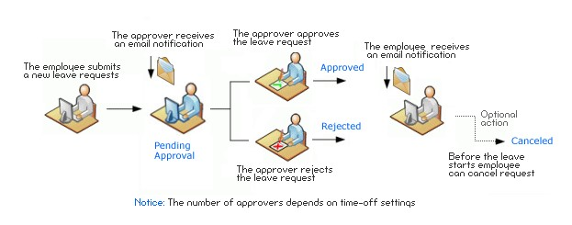

# DATABASE - LEAVE MANAGEMENT SYSTEM PROJECT

## 6.3. NORMALIZATION

It is a process of converting a relation to a standard form. The process is used to handle the problems that can arise due to data redundancy i.e. repetition of data in the database, maintain data integrity as well as handling problems that can arise due to insertion, updation, deletion anomalies.

Decomposing is the process of splitting relations into multiple relations to eliminate anomalies and maintain anomalies and maintain data integrity. To do this we use normal forms or rules for structuring relation.

**Insertion anomaly**: Inability to add data to the database due to absence of other data.

**Deletion anomaly**: Unintended loss of data due to deletion of other data.

**Update anomaly**: Data inconsistency resulting from data redundancy and partial update

**Normal Forms**: These are the rules for structuring relations that eliminate anomalies.

**FIRST NORMAL FORM:**

A relation is said to be in first normal form if the values in the relation are atomic for every attribute in the relation. By this we mean simply that no attribute value can be a set of values or, as it is sometimes expressed, a repeating group.

**SECOND NORMAL FORM**:

A relation is said to be in second Normal form is it is in first normal form and it should satisfy any one of the following rules.

1. Primary key is a not a composite primary key
2. No non key attributes are present
3. Every non key attribute is fully functionally dependent on full set of primary key.

**THIRD NORMAL FORM**:

A relation is said to be in third normal form if their exits no transitive dependencies.

Transitive Dependency: If two non key attributes depend on each other as well as on the primary key then they are said to be transitively dependent.

The above normalization principles were applied to decompose the data in multiple tables thereby making the data to be maintained in a consistent state.

**6.4. E – R DIAGRAMS - EMPLOYEE LEAVE MANAGEMENT SYSTEM**

# PROJECT

* The relation upon the system is structure through a conceptual ERDiagram, which not only specifics the existential entities but also the standard relations through which the system exists and the cardinalities that are necessary for the system state to continue.
* The entity Relationship Diagram (ERD) depicts the relationship between the data objects. The ERD is the notation that is used to conduct the date modeling activity the attributes of each data object noted is the ERD can be described resign a data object descriptions.
* The set of primary components that are identified by the ERD are o Data Object o Relationship o Attribute

o Various type of indicator

The primary purpose of the ERD is to represent data objects and their relationships.

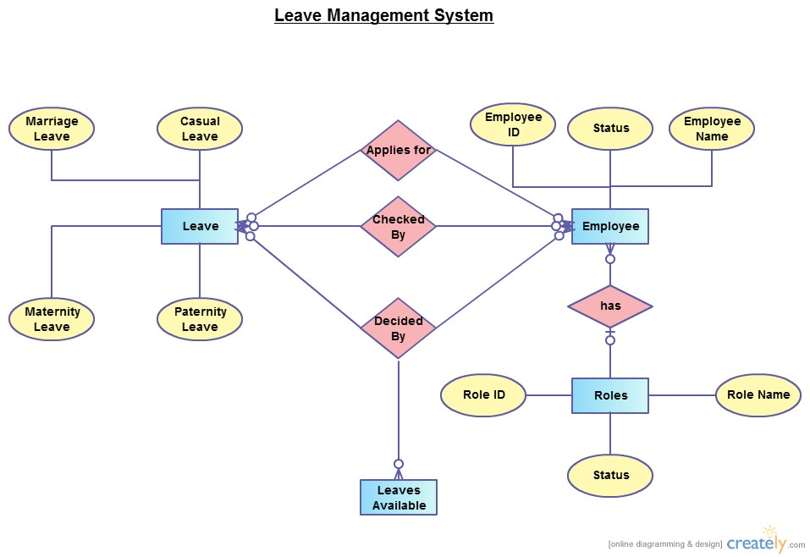

**6.4. DATA FLOW DIAGRAMS -EMPLOYEE LEAVE MANAGEMENT**

# SYSTEM PROJECT

A data flow diagram is graphical tool used to describe and analyze movement of data through a system. These are the central tool and the basis from which the other components are developed. The transformation of data from input to output, through processed, may be described logically and independently of physical components associated with the system. These are known as the logical data flow diagrams. The physical data flow diagrams show the actual implements and movement of data between people, departments and

workstations. A full description of a system actually consists of a set of data flow diagrams. Using two familiar notations Yourdon, Gane and Sarson notation develops the data flow diagrams. Each component in a DFD is labeled with a descriptive name. Process is further identified with a number that will be used for identification purpose. The development of DFD‟S is done in several levels. Each process in lower level diagrams can be broken down into a more detailed DFD in the next level. The lop-level diagram is often called context diagram. It consists a single process bit, which plays vital role in studying the current system. The process in the context level diagram is exploded into other process at the first level DFD.

The idea behind the explosion of a process into more process is that understanding at one level of detail is exploded into greater detail at the next level. This is done until further explosion is necessary and an adequate amount of detail is described for analyst to understand the process.

Larry Constantine first developed the DFD as a way of expressing system requirements in a graphical from, this lead to the modular design.

A DFD is also known as a “bubble Chart” has the purpose of clarifying system requirements and identifying major transformations that will become programs in system design. So it is the starting point of the design to the lowest level of detail. A DFD consists of a series of bubbles joined by data flows in the system.

**DFD SYMBOLS:**

In the DFD, there are four symbols

1. A square defines a source(originator) or destination of system data
2. An arrow identifies data flow. It is the pipeline through which the information flows
3. A circle or a bubble represents a process that transforms incoming data flow into outgoing data flows.
4. An open rectangle is a data store, data at rest or a temporary repository of data

**CONSTRUCTING A DFD:**

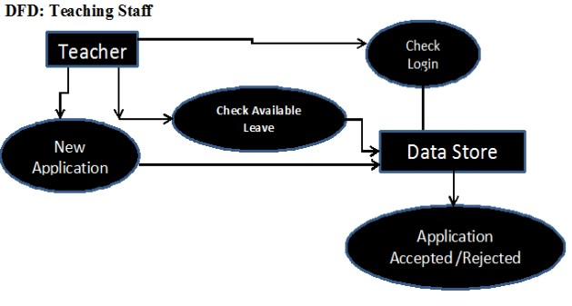

1. Process should be named and numbered for an easy reference. Each name should be representative of the process.
2. The direction of flow is from top to bottom and from left to right. Data traditionally flow from source to the destination although they may flow back to the source. One way to indicate this is to draw long flow line back to a source. An alternative way is to repeat the source symbol as a destination. Since it is used more than once in the DFD it is marked with a short diagonal.
3. When a process is exploded into lower level details, they are numbered.
4. The names of data stores and destinations are written in capital letters.

Process and dataflow names have the first letter of each work capitalized

A DFD typically shows the minimum contents of data store. Each data store should contain all the data elements that flow in and out.

Questionnaires should contain all the data elements that flow in and out. Missing interfaces redundancies and like is then accounted for often through interviews.

**CHAPTER 7**

**SCREENSHOTS**

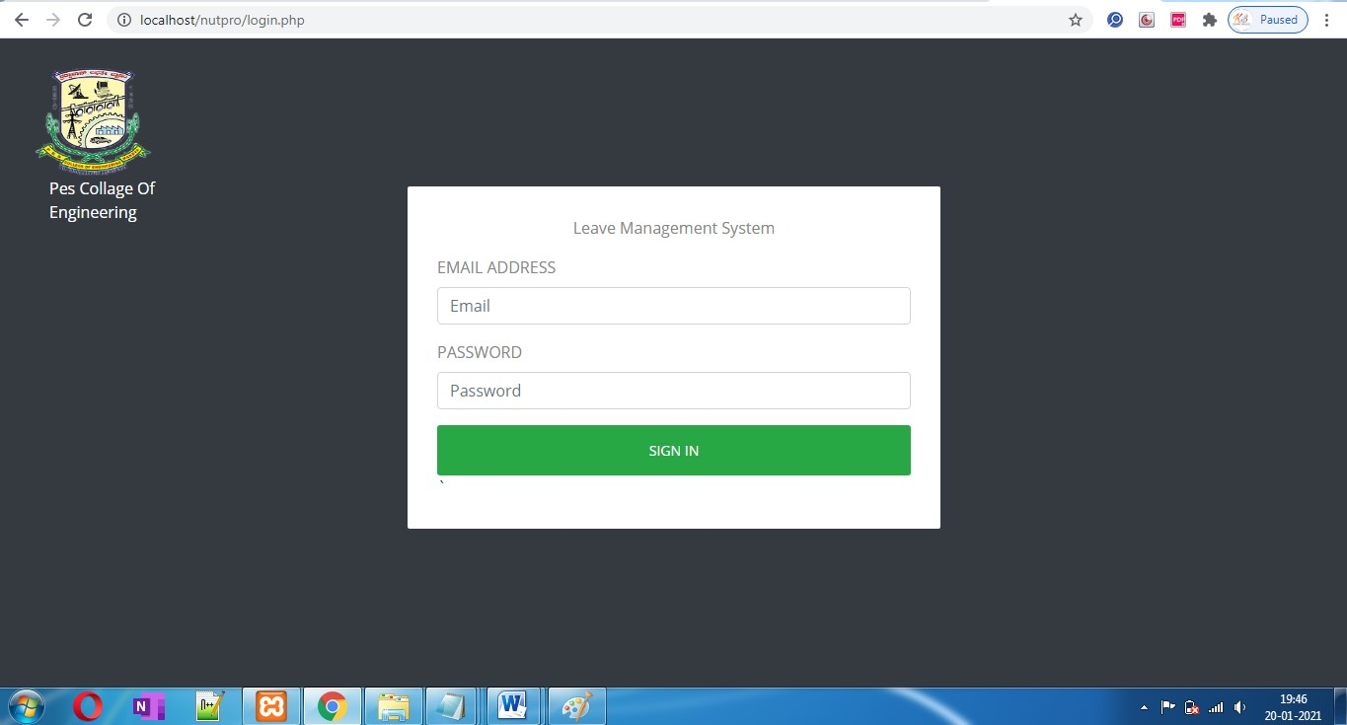

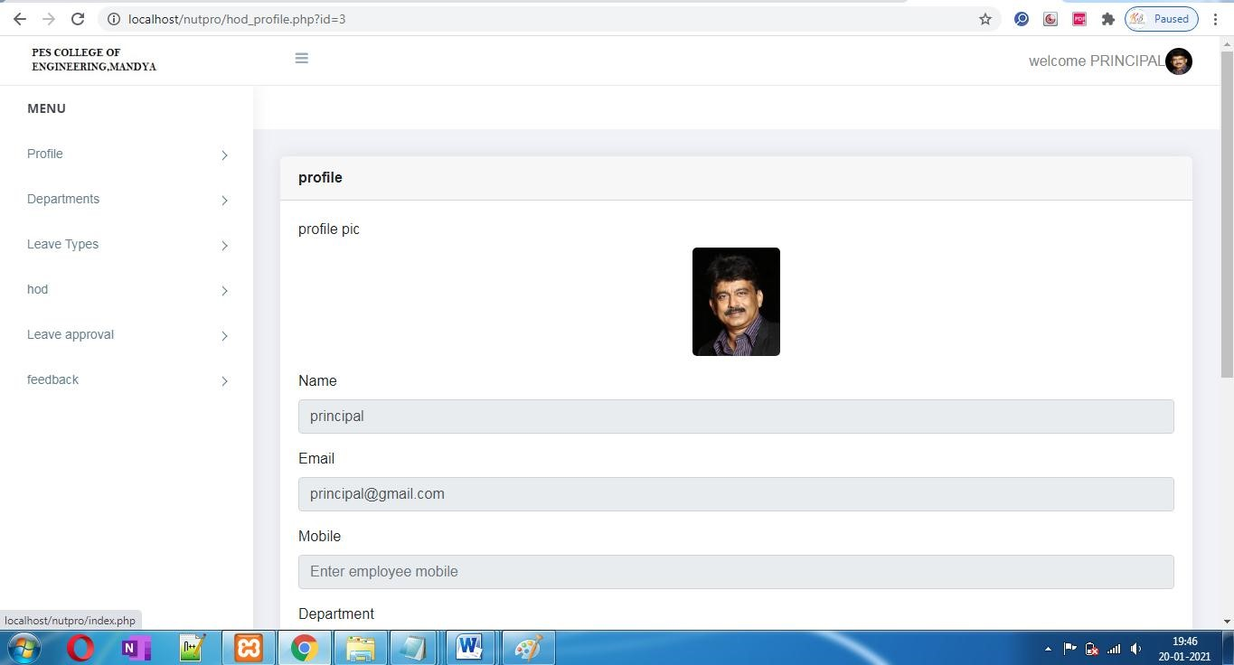

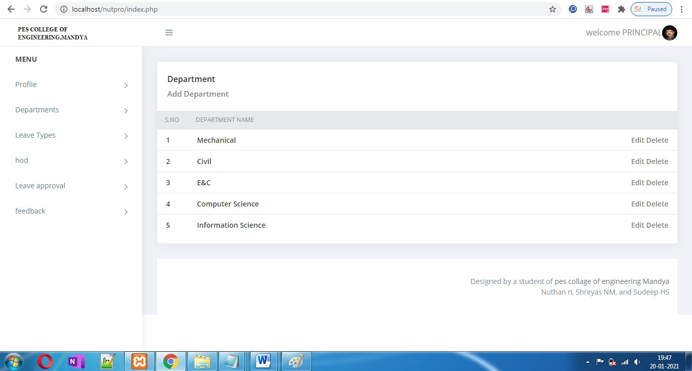

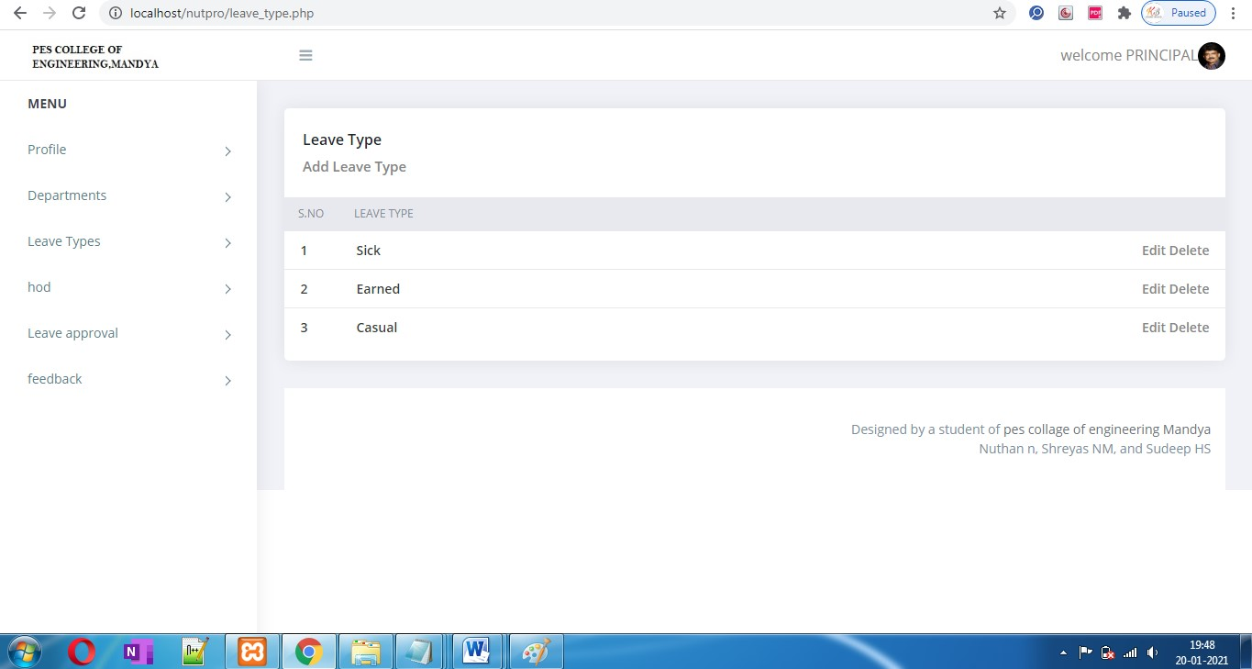

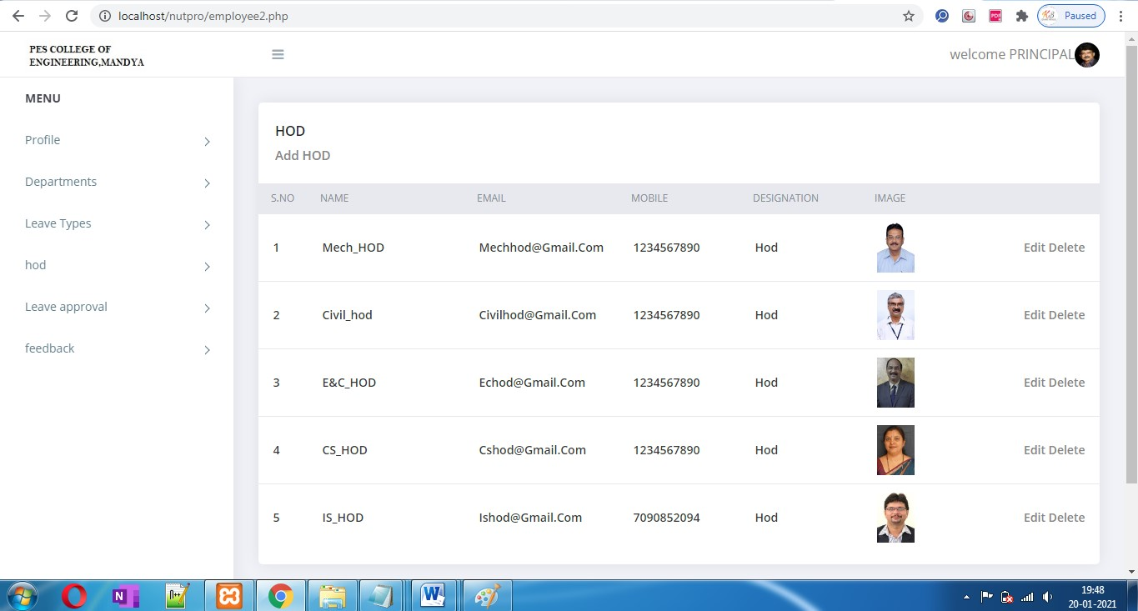

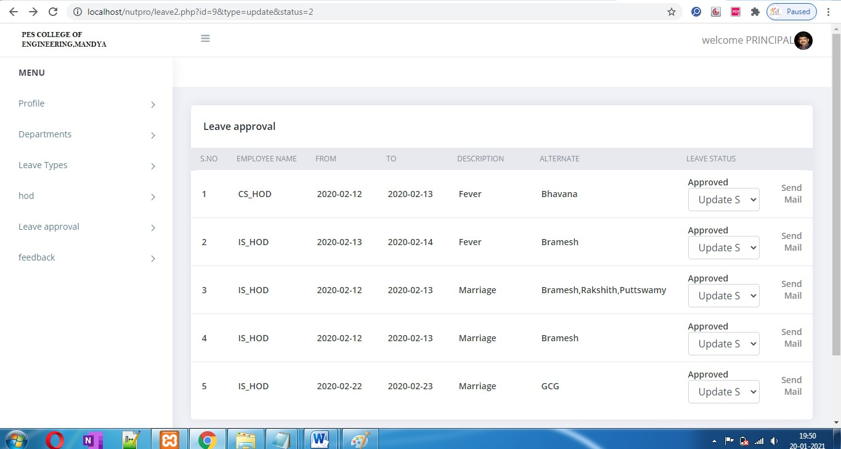

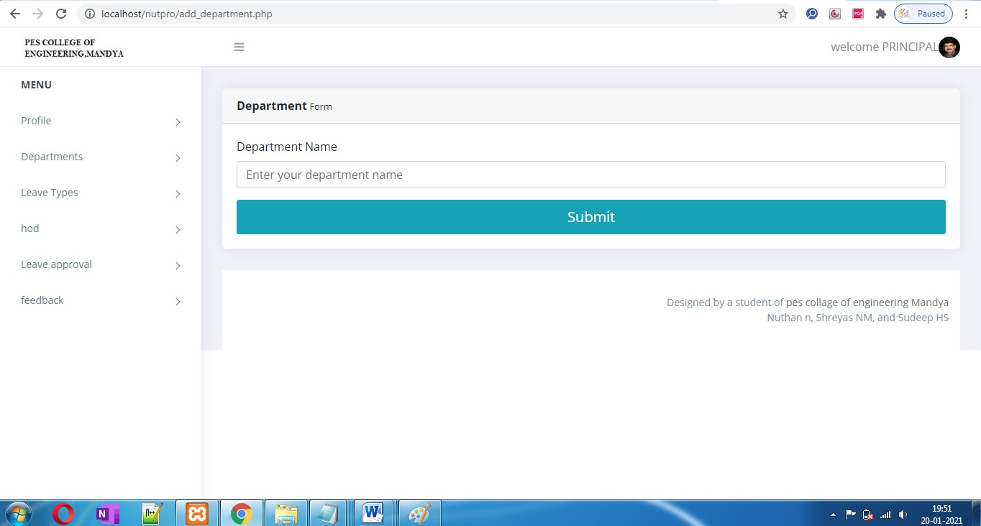

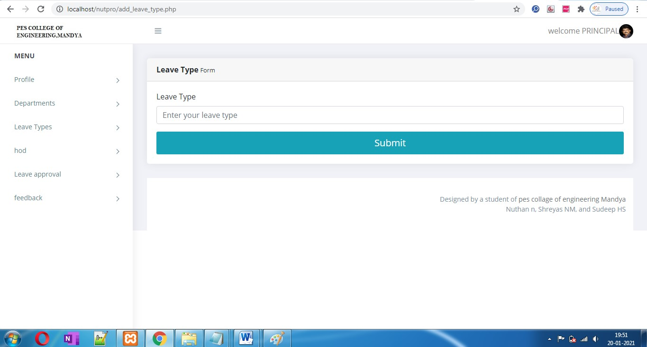

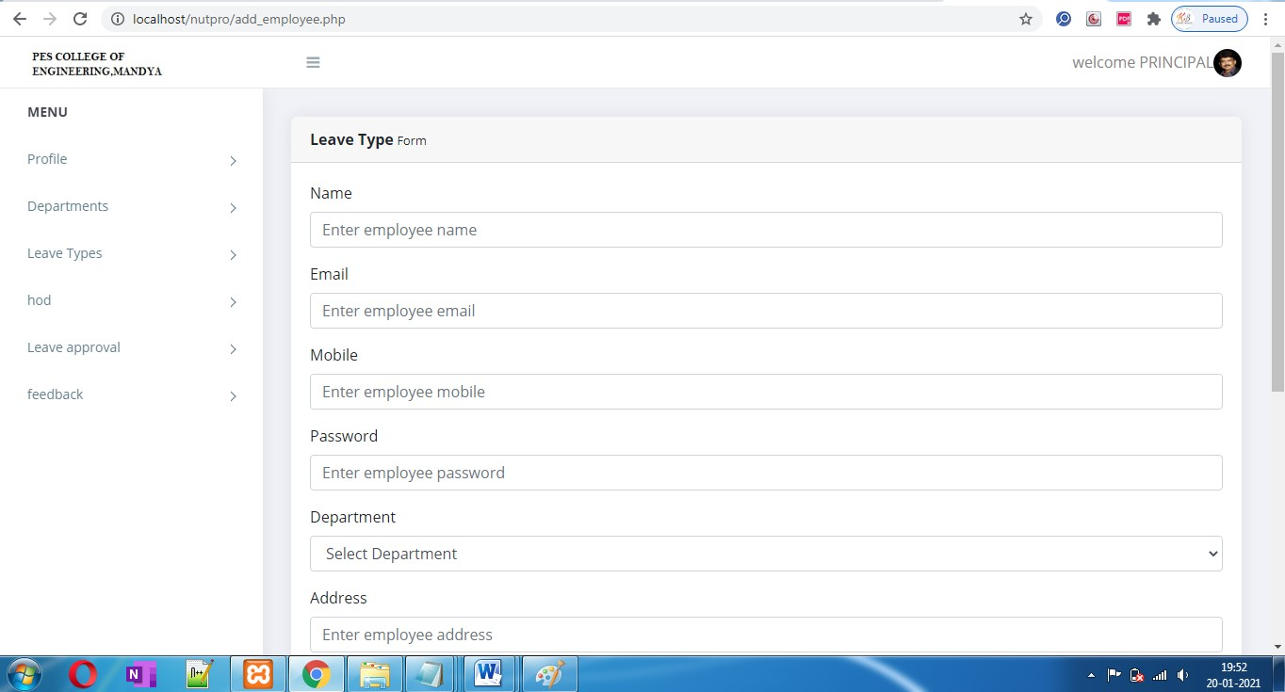

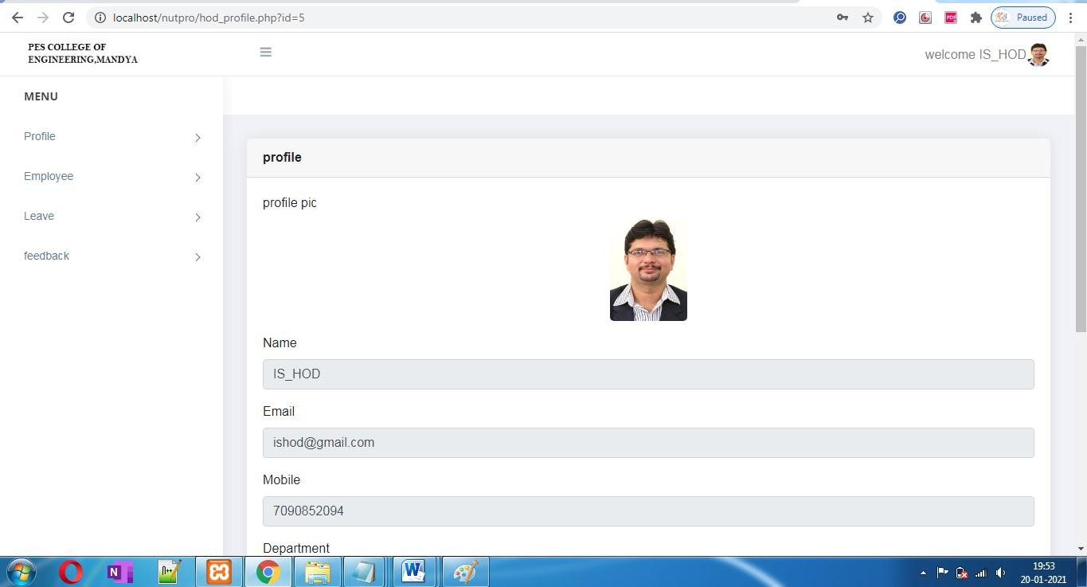

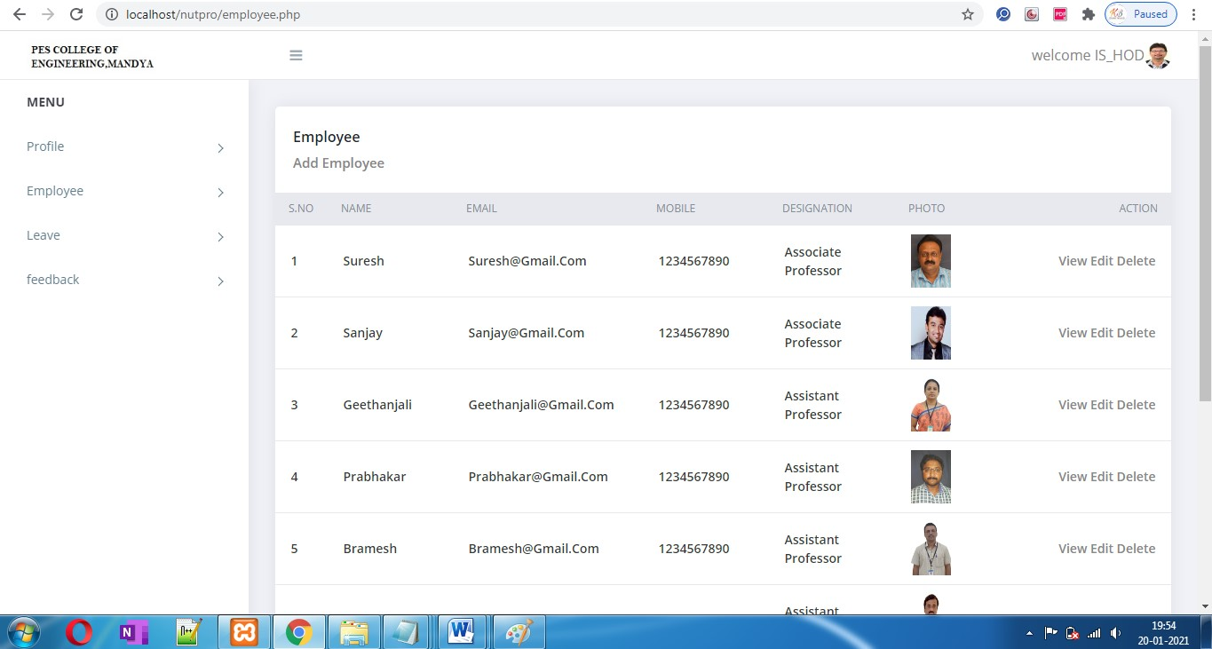

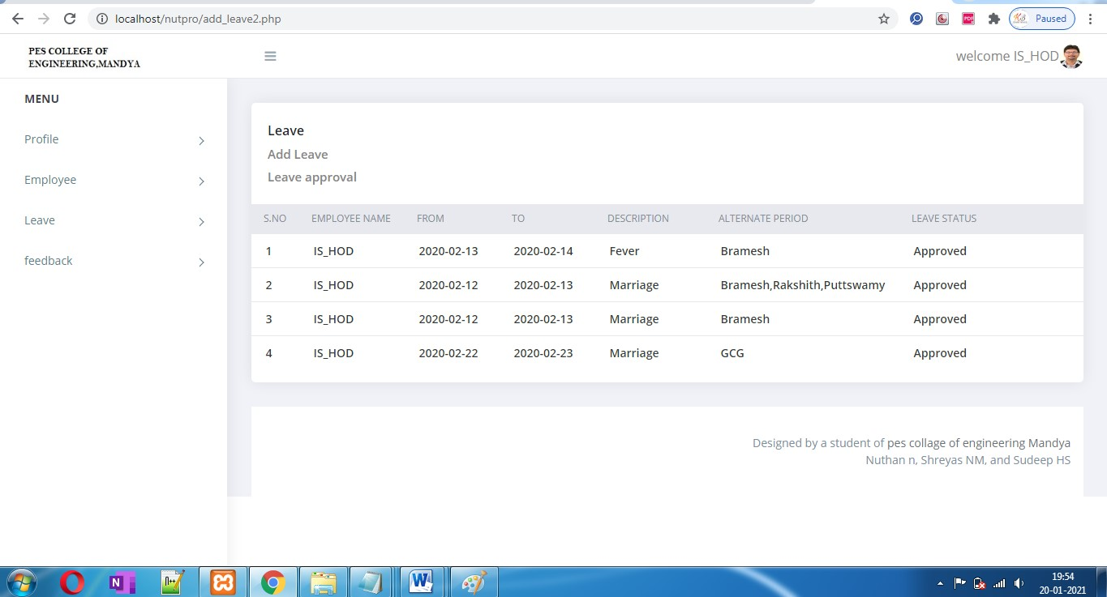

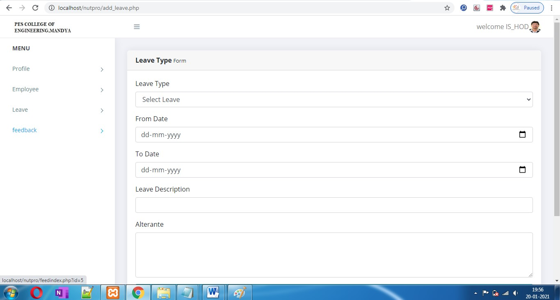

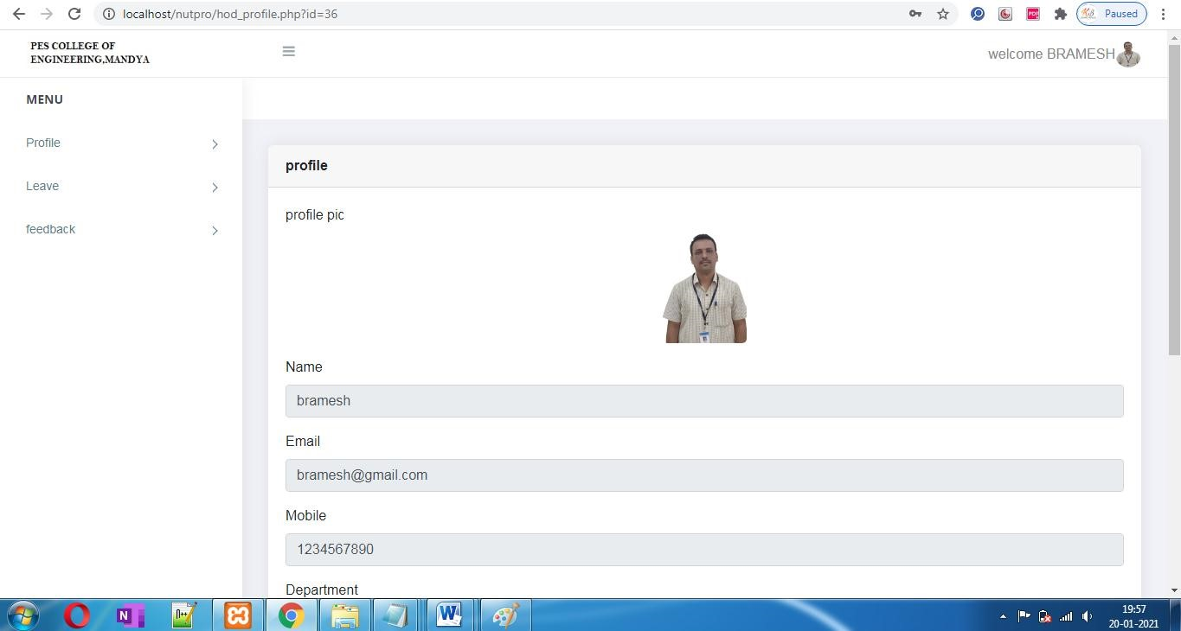

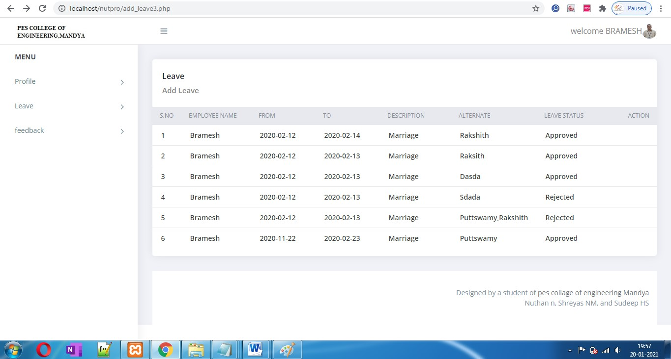

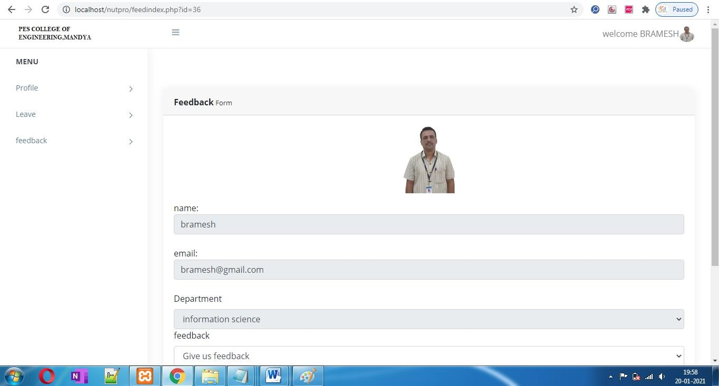

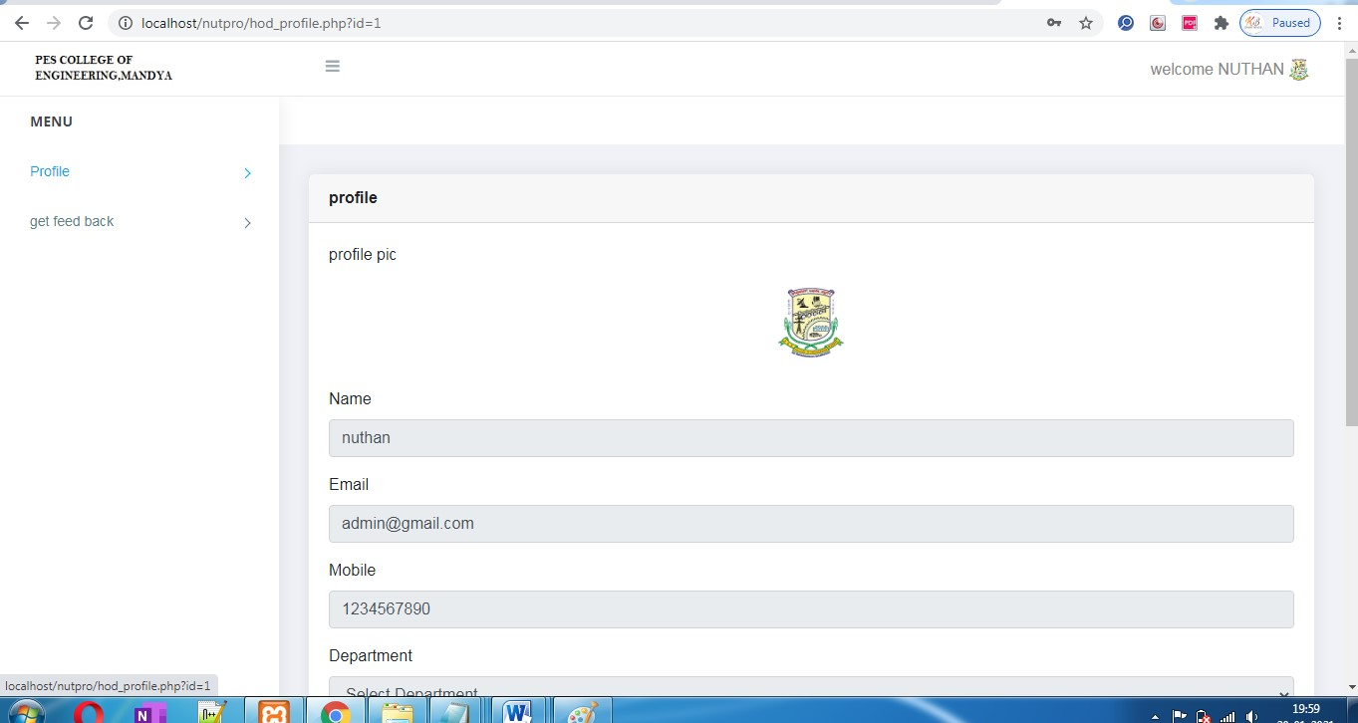

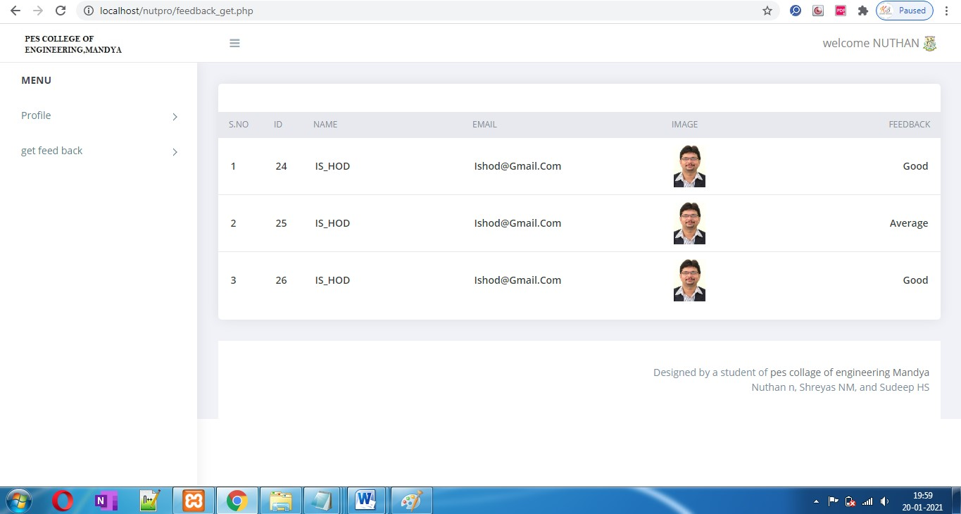

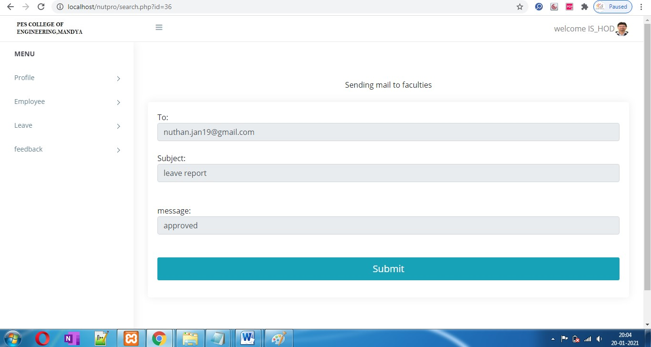

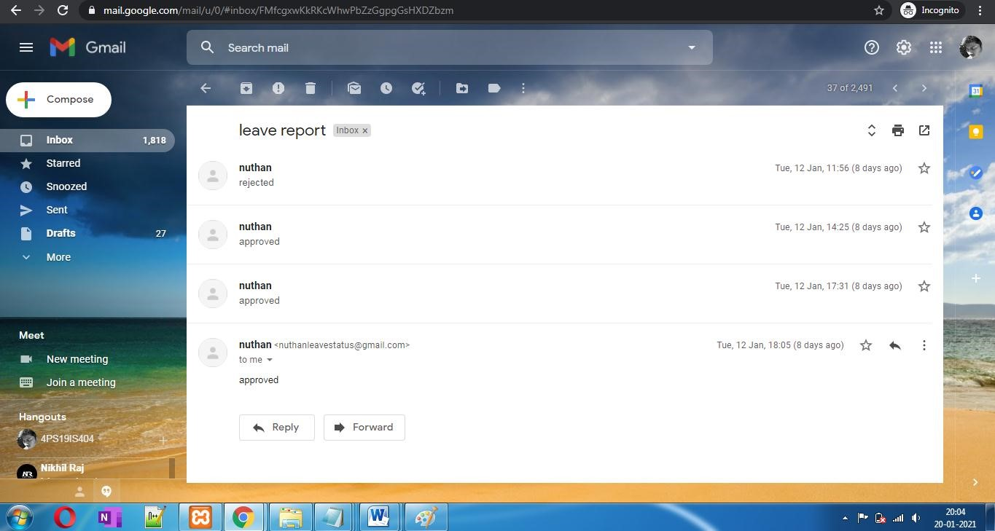

**CHAPTER 8**

## SYSTEM TESTING AND IMPLEMENTATION - EMPLOYEE LEAVE MANAGEMENT SYSTEM PROJECT

### 8.1. INTRODUCTION

Software testing is a critical element of software quality assurance and represents the ultimate review of specification, design and coding. In fact, testing is the one step in the software engineering process that could be viewed as destructive rather than constructive.

A strategy for software testing integrates software test case design methods into a well-planned series of steps that result in the successful construction of software. Testing is the set of activities that can be planned in advance and conducted systematically. The underlying motivation of program testing is to affirm software quality with methods that can economically and effectively apply to both strategic to both large and small-scale systems.

### 8.2. STRATEGIC APPROACH TO SOFTWARE TESTING

The software engineering process can be viewed as a spiral. Initially system engineering defines the role of software and leads to software requirement analysis where the information domain, functions, behavior, performance, constraints and validation criteria for software are established. Moving inward along the spiral, we come to design and finally to coding. To develop computer software we spiral in along streamlines that decrease the level of abstraction on each turn.

A strategy for software testing may also be viewed in the context of the spiral. Unit testing begins at the vertex of the spiral and concentrates on each unit of the software as implemented in source code. Testing progress by moving outward along the spiral to integration testing, where the focus is on the design and the construction of the software architecture. Talking another turn on outward on the spiral we encounter validation testing where requirements established as part of software requirements analysis are validated against the software that has been constructed. Finally we arrive at system testing, where the software and other system elements are tested as a whole.

### 8.3. Unit Testing

Unit testing focuses verification effort on the smallest unit of software design, the module. The unit testing we have is white box oriented and some modules the steps are conducted in parallel.

### 1. WHITE BOX TESTING

This type of testing ensures that

· All independent paths have been exercised at least once

· All logical decisions have been exercised on their true and false sides

· All loops are executed at their boundaries and within their operational bounds

· All internal data structures have been exercised to assure their validity.

To follow the concept of white box testing we have tested each form .we have created independently to verify that Data flow is correct, All conditions are exercised to check their validity, All loops are executed on their boundaries.

### 2. BASIC PATH TESTING

Established technique of flow graph with Cyclomatic complexity was used to derive test cases for all the functions. The main steps in deriving test cases were:

Use the design of the code and draw correspondent flow graph.

Determine the Cyclomatic complexity of resultant flow graph, using formula:.

### 3. CONDITIONAL TESTING

In this part of the testing each of the conditions were tested to both true and false aspects. And all the resulting paths were tested. So that each path that may be generate on particular condition is traced to uncover any possible errors.

### 4. DATA FLOW TESTING

This type of testing selects the path of the program according to the location of definition and use of variables. This kind of testing was used only when some local variable were declared. The definition-use chain method was used in this type of testing. These were particularly useful in nested statements.

### 5. LOOP TESTING

In this type of testing all the loops are tested to all the limits possible. The following exercise was adopted for all loops:

### 8.4 Testing results in project

|  |  |  |  |  |  |
| --- | --- | --- | --- | --- | --- |
| **Sl.no** | **TestCase**  **Name** | **Test case details** | **Input** | **Expected output** | **Actual**  **Output** |
| 1 | User Login | User Email and Password | If accepted based on the details | Login must be done | Login id done |
| 2 | Update  Profile | Update  details of user | If accepted based on the details | Accept the data | accepted |
| 3 | Apply for leave | Take all the details | If accepted based on the details | Accepted  The data | accepted |
| 4 | Send mail | Send the mail to user | Send the mail based on status | sended | sended |
| 5 | Approve the leave | Approve the leave | Approve the leave based on details | Approved | Approved |
| 6 | Showing  status | Showing  the status of  employee | Approved  Or rejected | Show the status | showed |
| 7 | Enter wrong email | It must show error message | Wrong email | Showed  error message | showed |

**CHAPTER 9**

## SYSTEM SECURITY

### 9.1. Introduction

The protection of computer based resources that includes hardware, software, data, procedures and people against unauthorized use or natural

Disaster is known as System Security.

System Security can be divided into four related issues:

* Security
* Integrity
* Privacy
* Confedeniatlity

SYSTEM SECURITY refers to the technical innovations and procedures applied to the hardware and operation systems to protect against deliberate or accidental damage from a defined threat.

DATA SECURITY is the protection of data from loss, disclosure, modification and destruction.

SYSTEM INTEGRITY refers to the power functioning of hardware and programs, appropriate physical security and safety against external threats such as eavesdropping and wiretapping.

PRIVACY defines the rights of the user or organizations to determine what information they are willing to share with or accept from others and how the organization can be protected against unwelcome, unfair or excessive dissemination of information about it.

### 9.2. SECURITY IN SOFTWARE

System security refers to various validations on data in form of checks and controls to avoid the system from failing. It is always important to ensure that only valid data is entered and only valid operations are performed on the system. The system employees two types of checks and controls:

CLIENT SIDE VALIDATION

Various client side validations are used to ensure on the client side that only valid data is entered. Client side validation saves server time and load to handle invalid data.

CONFIDENTIALITY is a special status given to sensitive information in a database to minimize the possible invasion of privacy. It is an attribute of information that characterizes its need for protection.

**CHAPTER 10**

## CONCLUSION - LEAVE MANAGEMENT SYSTEM PROJECT

It has been a great pleasure for me to work on this exciting and challenging project. This project proved good for me as it provided practical knowledge of not only programming in PHP and HTML/CSS web based application and no some extent Windows Application and SQL Server, but also about all handling procedure related with “LEAVE MANAGEMENT SYSTEM”. It also provides knowledge about the latest technology used in developing web enabled application and client server technology that will be great demand in future. This will provide better opportunities and guidance in future in developing projects independently.